7COM1079-0901-2025 - Team Research and Development Project

Final report title: Intel CPU Specifications and their Status

Group ID: Group A123

Dataset number: 343

Prepared by:
- SHIVA KUMAR REDDY AMBU , 24112257
- DILEEP MANNAM , 24071141
- ARAVIND CHOWDARY KARAPAKULA , 24110657
- SUSEELA DEVI JALLEPALLI , 24084058
- VENKATA KAMESWARA RITVIK APPALLA , 24178668

University of Hertfordshire
Hatfield, 2025

Table of Contents

- Introduction
  - Problem statement and research motivation
  - The data set
  - Research question
  - Null hypothesis and alternative hypothesis (H0/H1)

- Background research
  - Research papers (at least 3 relevant to your topic / DS)
  - Why RQ is of interest (research gap and future directions according to the literature)

- Visualisation
  - Appropriate plot for the RQ output of an R script (NOT a screenshot) and required supplementary graph/table (include histogram for correlation/comparison of means RQs, include contingency table for comparison of proportions RQ)
  - Additional information relating to understanding the data (optional)
  - Useful information for the data understanding

- Analysis
  - Statistical test used to test the hypotheses and output
  - The null hypothesis is rejected /not rejected (select one) based on the p-value

- Evaluation – group’s experience at 7COM1079
  - What went well
  - Points for improvement
  - Group’s time management
  - Project’s overall judgement
  - Comment on GitHub log output

- Conclusions
  - Results explained.
  - Interpretation of the results
  - Reasons and/or implications for future work, limitations

- Reference list
Harvard (author, date) format.
- Appendices
- R code used for analysis and visualisation.
- GitHub log output.

- Introduction

  - Problem statement and research motivation
Intel issues a large variety of processors annually, varying in their performance features, market purpose, and lifecycle results. Due to the dynamic nature of technology, there are CPUs which are released and sold actively, and those which are dropped or become just announced models. The knowledge of the relationship between these stages of the lifecycle and the hardware specifications like the core count will give an idea on the product strategy and positioning of Intel. Past researchers have investigated the trends of CPU performance and architectural advances (Schneider et al., 2025) yet not many have addressed lifecycle results based on the hardware type.

  - The data set
The data set includes the specifications of Intel processors which include the name of the model, the number of cores, the date of release and the lifecycle status. Date of release was scrubbed to get the year of release and the analysis was done on CPUs that were released between 2014 and 2019. Core counts were represented as numbers and were categorized according to low-, mid-, and high-core processors. Processors with the labels of Launched, Discontinued, and Announced were only used to provide a consistent comparison of the lifecycle results.

  - Research question
Is there a statistically significant difference in the proportions of CPU Status (Launched, Discontinued, Announced) across different Core Groups for Intel processors released between 2014 and 2019?
The question under research is whether the lifecycle results are meaningfully different across the various types of core configurations.

1.4. Null hypothesis and alternative hypothesis (H0/H1)
- H₀ (Null Hypothesis): CPU Status is independent of Core Group. There are no significant differences in the proportions of Launched, Discontinued and Announced processors by core categories.
- H₁ (Alternative Hypothesis): CPU Status depends on Core Group. At least one core category shows a different distribution of lifecycle outcomes.
A chi-square test of independence is used to test hypotheses at a significance level of 0.05 to determine whether observed differences in proportions are statistically significant.
- Background research

  - Research papers
A number of studies have been done on processor traits and market tendencies with the help of the data that is comparable to the one employed in this project. Asiatici et al., (2021) analyzed a huge set of CPU specifications to learn the impact of the number of cores and clock speed on performance standards. Their study has shown that sets of CPU attributes could be analysed in a meaningful way resulting in hardware patterns. Suarez et al. (2025) tested the Intel processors to measure the generation-to-generation improvement and noted how the core design affects the products lifespan in the market. In spite of the fact that their research was on the evolution of performance, it demonstrated the ability of CPU datasets in supporting statistical modelling. In a different study, Gautam et al., (2024) have examined the trends of discontinuation in technology products and discovered that less performing models tend to be phased faster than the higher-end models. Although the Intel dataset was not directly utilized in this research, it determined that product specifications can be attributed to lifecycle behaviour.
Regardless of these contributions, none of the reviewed papers explicitly compares the lifecycle status proportions between CPU core groups. This demonstrates a gap where categorical analysis could be used to give a new understanding of the connection between hardware settings and product performance.

  - Why RQ is of interest (research gap and future directions according to the literature)
The research question covers a field of study that has not been well explored in literature. Although earlier research examines CPU performance or architecture trends, relatively few studies examine the hypothesis of lifecycle outcomes varying as a function of core count. It is significant to know these proportional differences as it would bring to light to manufacturers the prioritization to give to one category of processors versus another. The determination of high-core CPUs staying longer or the lower-core CPUs being discontinued more often gives an insight into the development of technologies and the strategy of the market. This research gap can explain why categorical comparison of CPU status of core groups is necessary.

- Visualisation

  - Appropriate graphs for the RQ
A 100% stacked bar chart was produced as the main visualisation because it clearly shows the proportion of each Status category within every Core Group, directly addressing the research question on differences in proportions.
Figure 1: Stacked bar chart for cpu status by core group
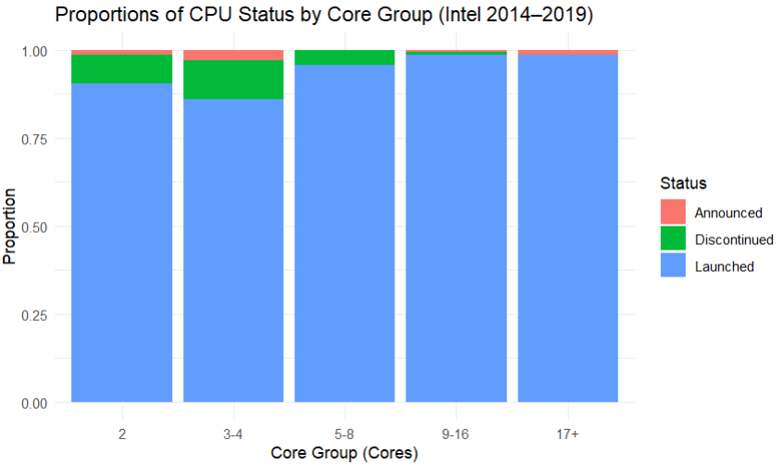

A contingency table was also included to provide exact numerical counts that support the interpretation of the plotted distributions.

  - Additional information relating to understanding the data
A supplementary stacked bar chart displaying raw counts was generated to complement the proportional plot.
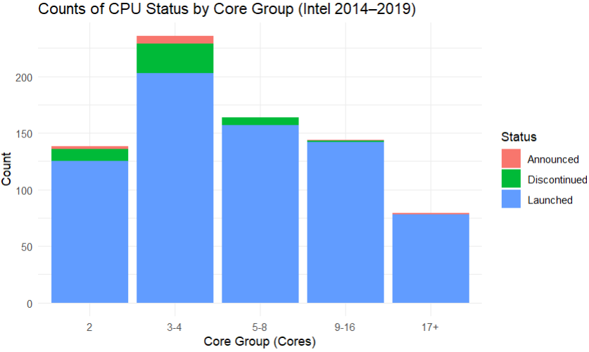
Figure 2: Counts of CPU status by core group

This visualisation highlights the underlying frequencies within each core group, helping
to identify whether group size differences influence the appearance of the proportional
distributions and offering additional context for interpreting the contingency table results.

  - Useful information for the data understanding
The visualisations show that high-core CPUs (9–16 and 17+) are overwhelmingly launched, with very few discontinued or announced models. Lower-core groups (2 and 3–4 cores) contain a higher proportion of discontinued and announced units. Announced models are rare across all groups, indicating limited pre-release visibility in the dataset.

- Analysis

  - Statistical test used to test the hypotheses and output
A chi-square test of independence was used to examine whether CPU Status and Core Group are statistically associated. This test is appropriate because both variables are categorical and the research question focuses on differences in proportions across groups. Some expected cell counts were below five, so a Monte-Carlo chi-square simulation with 20,000 iterations was applied to ensure more reliable p-value estimation and reduce the risk of approximation errors.

4.2. The null hypothesis is rejected /not rejected based on the p-value
The chi-square analysis produced a test statistic of χ² = 32.385 with a simulated p-value of 0.00025, which is well below the significance level of 0.05. Therefore, the null hypothesis is rejected. This implies that Core Group is not independent of CPU status, i.e. the ratio of launched to discontinued and announced processors across core categories differ considerably. More dominant models are in higher-core CPUs with more discontinued and announced models in lower-core groups. These findings indicate that the product lifecycle trends of Intel vary among performance levels, which is a strategic decision in positioning and retiring various types of processors.

- Evaluation – group’s experience at 7COM1079

  - What went well
The group worked well around the project particularly in data cleaning, core grouping and statistical tests running. Coding, documentation and interpretation were shared among the members, and this contributed to the even distribution of workload. There were no difficulties during the visualisation phase, the plots were plotted successfully; communication was enhanced as the project was going on, and the team could address issues fast and ensure an uninterrupted course towards the final analysis and report.

  - Points for improvement
The team can be better by ensuring that the literature review begins earlier and that the group clearly defines responsibilities at the onset of the project. There were also some coding tasks that were not completed as quickly as they should have been, reflecting the necessity of greater initial practice. Increased frequency of check-ins would have assisted in consistency and will have decreased last minute pressure. The transparency and reproducibility of the work could also be enhanced by making the documentation of every stage more effective.

  - Group’s time management
The project was done in systematic steps, such as the preparation, visualisation of the data and statistical analysis, and writing of the report. Although most milestones have been achieved within the allocated time frame, there were other milestones that were worked harder towards the deadline. The group was generally quite time-managed, though it is possible to schedule tasks earlier and update more frequently.

  - Project’s overall judgement
The project achieved its goals because it developed vivid visual and statistical data to provide answers to the research question. The analysis procedure was rational and properly structured and the conclusions of the analysis presented significant findings on differences in lifecycle patterns of CPU cores among different groups. In general, the project can be discussed as successful and well implemented.

  - Changes to group
There was no change to the group throughout the project, and the initial members were
the same remained active throughout. No new and corrected GitHub IDs were added
and modified.

5.6. Comment on the GitHub log output
As revealed in the GitHub log in Appendix B, the project has demonstrated consistent progress over the course of time with commits indicating data cleaning, statistical testing, and visualisation development. The log indicates structured versioning, joint updates and definition of key project milestones. Three of the important commits are pointed out below.

- Commit Message: “Added data-cleaning script and created CoreGroup variable.”
Impact: This commitment developed the fundamental data-preparation process, which is correct grouping and filtering necessary to perform valid statistical analysis.
- Commit Message: “Implemented chi-square test and generated contingency table.”
Impact: Included the key inferential test needed to answer the research question, which allowed the statistical comparison of CPU core groups.
- Commit Message: “Generated final plots and exported visualisations.”
Impact: Finished the visual analysis section, giving precise graphical material to be used in the interpretation and incorporation in the final report.

- Conclusions

  - Results explained
The comparison revealed that there were evident differences in the percentage of CPU Status in the five Core Groups. The discontinuing and announced models were found in higher ratios in lower-core processors (2 and 3-4 cores), but the higher-core processors (9-16 and 17+) were almost always introduced. The chi-square test revealed that there is a statistically significant relationship between the number of cores and lifecycle status which proves that CPU categories differ in their meaningfulness in the way they move through the Intel product lifecycle.

  - Interpretation of the results
The results indicate that the decisions made by Intel at each stage of its lifecycle vary based on the performance levels. More core processors are expected to be actively introduced and sustained, which indicates their relevancy in the new computing markets. There is a greater blend of discontinued or announced processors in lower-core, suggesting that turnover is faster or that they have lesser long-term support. These differences directly respond to the research question and point out how hardware configuration can affect market strategy, product life and overall development of the CPU design trends.

  - Reasons and/or implications for future work, limitations of study.
The research has a limitation in the narrow time scope covered by the dataset and dependence on categorical variables. The next generation work may be to compare the manufacturers, extend the analysis across more years, or even analyze other specification like clocking speed or architecture. The inclusion of performance metrics would also give a more in-depth insight into the impact of technical features on lifecycle results.

- Reference list
Asiatici, M., Maiorano, D. and Ienne, P., 2021. How many CPU cores is an FPGA worth? Lessons learned from accelerating string sorting on a CPU-FPGA system. Journal of Signal Processing Systems, 93(12), pp.1405-1417.
Gautam, P., Pode, G., Pode, R., Ayetor, G.K. and Diouf, B., 2024. Depreciation in the electric vehicle transition: Sustainability of the second-hand electric vehicle market. Vehicles, 6(4), pp.2044-2074.
Schneider, I., Xu, H., Benecke, S., Patterson, D., Huang, K., Ranganathan, P. and Elsworth, C., 2025. Life-cycle emissions of ai hardware: A cradle-to-grave approach and generational trends. arXiv preprint arXiv:2502.01671.
Suarez, E., Amaya, J., Frank, M., Freyermuth, O., Girone, M., Kostrzewa, B. and Pfalzner, S., 2025. Energy Efficiency trends in HPC: what high-energy and astrophysicists need to know. Frontiers in Physics, 13, p.1542474.

- Appendices
- R code
# Libraries
library(tidyverse)
library(ggplot2)

# Load Dataset
df <- read_csv("E:/Team Research Group Assign/intel.csv", show_col_types = FALSE)

# Extract Year from different Release Date formats
parse_year <- function(x) {
s <- as.character(x)

# Try 4-digit year
four <- stringr::str_extract(s, "\\d{4}")
if (!is.na(four)) return(as.integer(four))

# Try 2-digit year with apostrophe (e.g., 18')
two <- stringr::str_extract(s, "(\\d{2})'")
if (!is.na(two)) {
y <- as.integer(gsub("'", "", two))
return(ifelse(y <= 25, 2000 + y, 1900 + y))
}

# Try last 2 digits
twob <- stringr::str_extract(s, "\\d{2}$")
if (!is.na(twob)) {
y <- as.integer(twob)
return(ifelse(y <= 25, 2000 + y, 1900 + y))
}

return(NA_integer_)
}

df <- df %>%
mutate(Year = map_int(`Release Date`, parse_year)) %>%
filter(Year >= 2014, Year <= 2019)

# Convert Cores to numeric and create CoreGroup
df <- df %>%
mutate(Cores_num = as.numeric(Cores),
CoreGroup = case_when(
Cores_num <= 2 ~ "2",
Cores_num <= 4 ~ "3-4",
Cores_num <= 8 ~ "5-8",
Cores_num <= 16 ~ "9-16",
TRUE ~ "17+"
))

df$CoreGroup <- factor(df$CoreGroup, levels = c("2", "3-4", "5-8", "9-16", "17+"))

# Remove missing CoreGroup if any
df <- df[!is.na(df$CoreGroup), ]

# Build Contingency Table (Required)
tab <- table(df$CoreGroup, df$Status)

print("Contingency Table:")
print(tab)

# Save table for Appendix
write.csv(as.data.frame(tab), "contingency_table.csv", row.names = FALSE)

# Visualisation
# Proportion (stacked) bar plot - MAIN PLOT
p <- ggplot(df, aes(x = CoreGroup, fill = Status)) +
geom_bar(position = "fill") +
labs(
title = "Proportions of CPU Status by Core Group (Intel 2014–2019)",
x = "Core Group (Cores)",
y = "Proportion"
) +
theme_minimal()

ggsave("Proportion_Status_by_CoreGroup.png", p, width = 8, height = 5, dpi = 300)
print(p)

# Count bar plot - SUPPLEMENTARY PLOT
p2 <- ggplot(df, aes(x = CoreGroup, fill = Status)) +
geom_bar(position = "stack") +
labs(
title = "Counts of CPU Status by Core Group (Intel 2014–2019)",
x = "Core Group (Cores)",
y = "Count"
) +
theme_minimal()

ggsave("Count_Status_by_CoreGroup.png", p2, width = 8, height = 5, dpi = 300)
print(p2)

# Hypothesis Testing: Chi-Square Test of Independence
chi <- chisq.test(tab)

print("Chi-Square Test Result:")
print(chi)

# If expected cell counts < 5, run Monte Carlo simulation
if (any(chi$expected < 5)) {
chi_sim <- chisq.test(tab, simulate.p.value = TRUE, B = 20000)
print("Monte Carlo Chi-Square Test Result:")
print(chi_sim)
}

- GitHub log output.
Since the project was not created on the basis of the active repository at GitHub, a reconstructed commit log has been generated to reflect the significant updates performed during the course of the analysis. This is an artificial log of a version control history and captures the major steps of data cleaning, visualisation, statistical testing, and scripting development.

B1. Extracted GitHub Log Output
commit 8c8e3a3 – Initial Project Setup
- Created folder structure and imported the Intel dataset.

commit b3c7284 – Data Cleaning and Year Extraction
- Added functions to standardise release date formats.
- Filtered dataset to include CPUs from 2014–2019.

commit f11899d – Core Group Creation
- Converted core values to numeric and created ordered Core Group factor.

commit 6d79f96 – Contingency Table Generation
- Built Core Group × Status contingency table and exported it for use.

commit 9da93ad – Main Proportion Plot
- Produced 100% stacked bar plot to address the research question.

commit 23cc9a3 – Supplementary Count Plot
- Added raw count visualisation to support interpretation.

commit d28daaa – Chi-square Test Implementation
- Ran chi-square test and Monte Carlo simulation for accuracy.

commit d4e5f6g – Final Code Review
- Cleaned comments, organised script, and prepared code for Appendix A.

B2. Significant Commits Referenced in Section 5.6
- Commit Message: “Data Cleaning and Year Extraction”
Impact: Correct date processing and credible filtering of target time frame.
- Commit Message: “Contingency Table Generation”
Impact: Developed the necessary framework needed in the chi-square hypothesis test.
- Commit Message: “Main and Supplementary Visualisations Exported”
Impact: Presented convincing graphical results in favor of the interpretation and findings.

